BLOCKCHAIN-BASED E-COMMERCE AND SERVICE PLATFORM WITH ESCROW AND SOCIAL MEDIA INTEGRATION FOR KENYAN SMES.
NAME: VICTOR KIPKORIR KIRUI
REG NO: SCT221-0111/2021
SUPERVISOR: DR. DENNIS KABURU

A proposal/ research project submitted to the Department of Information
Technology in the School of Information Technology in partial fulfillment of the
requirement for the award of the degree of BSc. Information Technology Jomo
Kenyatta University of Agriculture and Technology.

2024.

CHAPTER 3

SYSTEM ANALYSIS AND DESIGN

3.1 Introduction
This chapter presents the system analysis and design of Tredit, a blockchain-based e-commerce and service platform with escrow and social media integration for Kenyan SMEs. It encompasses the development methodology adopted (Agile), a multi-faceted feasibility study, the process of requirements elicitation and data analysis, and the detailed specification of functional and non-functional requirements. The chapter also includes system modeling using use case and data flow diagrams, followed by the logical design of the system architecture and process workflows. Finally, the physical design is described, covering the database schema and user interface prototypes.

3.2 System Development Methodology
The Agile methodology was selected as the system development approach for this project. Agile is characterized by iterative development, flexibility in adapting to change, and a high degree of stakeholder involvement. This choice is justified by the innovative nature of the Tredit platform, which integrates emerging technologies (blockchain, IPFS) and thus benefits from continuous feedback and incremental improvement. Agile methodologies embrace a human-centered, iterative approach by incorporating customer feedback early and often in the development lifecycle. In the context of Tredit, requirements such as user interface preferences or smart contract features could evolve as stakeholders (e.g., supervisors, target users) see early prototypes. Agile’s adaptability allows the refinement of these features in successive iterations, ensuring the final product is more user-centric and effective.
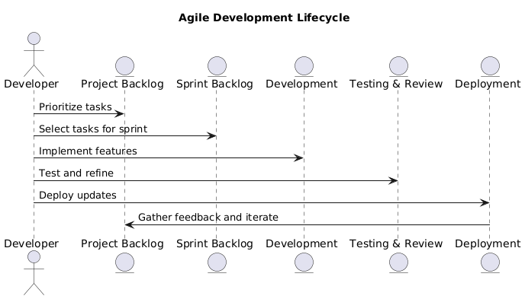
Figure 1 – Agile Development Lifecycle
In practice, the project followed a Scrum-inspired Agile process with short development sprints. Each sprint focused on delivering a set of features or improvements and getting feedback. This iterative cycle (illustrated in Figure 1 – Agile Development Lifecycle) enabled continuous improvement. The emphasis on frequent testing and client feedback reduced the risk of major issues and ensured the system’s functionality remained aligned with user expectations. Overall, Agile methodology provid the flexibility and responsiveness needed to successfully develop Tredit in a domain where requirements could not be fully predefined from the start.

3.3 Feasibility Study
A comprehensive feasibility study was conducted to evaluate the viability of the system from four perspectives: economic, technical, operational, and legal/regulatory feasibility. The findings of each aspect are detailed below.
- Economic Feasibility: The proposed system is economically viable and sustainable. Development leverages open-source technologies (Solidity, Polygon, IPFS, social media integration) which significantly lowers licensing costs. The primary costs involve development effort, deployment infrastructure (web hosting and possible IPFS pinning services), and minimal transaction fees on the blockchain. Notably, using the Polygon network for smart contracts keeps operational costs low – transaction fees on Polygon are approximately $0.01 making it affordable to perform escrow transactions even for low-value purchases. The platform’s revenue model can include a small escrow fee or commission on transactions, which in the Kenyan market must remain low to encourage adoption (e.g., a 1-2% fee or a fixed minor charge per transaction). The growing Kenyan e-commerce market suggests strong revenue potential: Kenya is the 3rd largest e-commerce market in Africa and its online shopping user base is expanding rapidly (Kenya - eCommerce). For instance, e-commerce revenues in Kenya are projected to grow at 16.4% annually through 2025 (Kenya - eCommerce), indicating a broad and increasing user base that could translate into significant transaction volume for the escrow service. This growth underpins a favorable Return on Investment (ROI) prospect. In summary, the benefits (increased trust leading to more transactions, commission revenues, reduced fraud losses) clearly outweigh the development and running costs, rendering Tredit economically feasible.
- Technical Feasibility: The system is technically feasible within the current technology landscape. All required technologies – blockchain (Polygon), smart contracts (Solidity), decentralized storage (IPFS), and web/mobile development frameworks – are mature and well-supported. Integrating with existing social media platforms enhances feasibility for users who have established their online presence, enabling them to boost sales more effectively. As social marketing continues to dominate, it offers a more effective approach compared to traditional marketing methods. Polygon was chosen for its high throughput and low latency, capable of handling up to 65,000 transactions per second and thus scaling well beyond the anticipated load (Polygon VS Ethereum: Understanding the Differences). IPFS provides a distributed file system to store product images and descriptions, eliminating reliance on a single server and ensuring content persistence. Integrating IPFS is achievable via existing libraries, and it significantly reduces on-chain data storage needs (Building DeFi with IPFS). On the user side, Kenya’s technology infrastructure supports this platform: internet penetration and smartphone usage are high, and the country’s population is accustomed to digital payments (e.g., mobile money). In fact, Kenya’s financial inclusion via mobile accounts is among the highest in Africa (Kenya - eCommerce), which implies that users are equipped to use online platforms like Tredit.
- Operational Feasibility: Operating the Tredit platform in a real-world context is considered practical. The system’s user-friendliness is a priority in design to ensure that buyers and sellers can use the platform with minimal training. On the administrative side, the platform will require management of escrow transactions and dispute resolution. We anticipate the need for a small operations team (initially, even one or two administrators) who can monitor transactions, handle customer service inquiries, and mediate disputes. The workflow for administrators is being designed with efficiency in mind: administrators will have access to an admin dashboard with summarized information on ongoing escrows and any disputes flagged, allowing them to take prompt action. Support processes (like responding to user questions or resetting account credentials) can be managed through existing channels (email or an in-app helpdesk). Because the blockchain automates the core escrow function (funds holding and release), the operational overhead is reduced – many transactions will complete without any manual intervention. The platform is also designed to integrate with familiar tools; for example, it can notify users via email or SMS (widely used in Kenya) for key events, and it could potentially integrate with mobile money workflows in the future to align with how users transact.
- Legal and Regulatory Feasibility: The legal environment for a blockchain-based escrow service in Kenya is largely supportive, though evolving. Currently, internet escrow services are not explicitly regulated in Kenya (The Future of Escrow Services in Kenya: Trends and Predictions). This means Tredit can operate without a specialized escrow license at present, though it must still comply with general laws. The platform will adhere to Kenya’s existing e-commerce and digital finance regulations. Kenya has legally recognized electronic transactions and signatures since the Kenya Communications (Amendment) Act 2008, which adopted the UN Model Law on E-Commerce (Kenya - eCommerce). This legal framework gives validity to electronic records and contracts, providing a solid basis for the smart-contract-driven agreements on Tredit. In terms of financial regulations, if Tredit handles cryptocurrency, it will operate in a careful manner since the Central Bank of Kenya has issued advisories about crypto but not banned it. We will ensure the platform clearly informs users of the nature of crypto assets (if used for payments) and implement measures to prevent illicit use (e.g., monitoring for money laundering red flags). Data protection is another critical legal aspect: Kenya’s Data Protection Act, 2019 mirrors many GDPR principles, requiring user consent for data collection, secure storage of personal data, and honoring deletion requests. Tredit will comply by obtaining explicit user consent for data use, protecting personal information (encrypting sensitive data in the database), and allowing users to exercise rights over their data. All user interactions will be governed by Terms and Conditions that outline the responsibilities of each party and the platform; users must accept these terms (including an escrow agreement) before conducting transactions, thereby providing legal protection and clarity. Intellectual property and content regulations are observed by storing user-uploaded content (product images/descriptions) on IPFS with proper user ownership attribution, and by disallowing illicit or infringing products on the platform. In summary, while the regulatory landscape for blockchain and escrow in Kenya is still developing, Tredit is legally feasible: it will operate within current laws and will be built to adapt to future regulations (e.g., by obtaining an escrow provider license or registration if such requirements emerge). Proactively following consumer protection best practices and data privacy laws will help avoid legal challenges and build trust among users and authorities.

3.4 Requirements Elicitation
A systematic approach was taken to elicit the requirements for the Tredit platform, ensuring they align with the project objectives and address user needs. Both qualitative and quantitative data gathering techniques were employed. The following sub-sections describe the data collection methods used, the sampling strategy, and how the elicited information relates to the project’s objectives.
- Data Collection Methods: The project utilized a combination of interviews and surveys to gather requirements. First, semi-structured interviews were conducted with key stakeholders – including three online marketplace users in Kenya (two frequent buyers and one independent seller) and one subject matter expert familiar with local e-commerce fraud issues. These interviews allowed open-ended exploration of pain points, trust issues, and desired features in an escrow service. Each interview followed a guide but also let the participant discuss any relevant concerns in depth. Insights from interviews (e.g., anecdotes of past fraud, suggestions for what would make them feel secure) provided qualitative understanding of user expectations. In parallel, a structured questionnaire survey was designed to collect input from a broader audience. The survey was created using Google Forms and distributed to potential ecommerce users. Using an online survey enabled reaching respondents across different locations quickly. The questionnaire consisted of concise, mostly close-ended questions (multiple choice and Likert scale) covering areas such as current online buying/selling behavior, trust and fraud experiences, potential usage of an escrow service, and feature preferences (for example, asking respondents to rank features like dispute resolution, delivery tracking, ratings, etc.). This survey approach yielded standardized data that is easy to analyze statistically. The use of multiple methods – interviews for depth and surveys for breadth – ensured a comprehensive collection of requirements: interviews captured detailed user stories and emotions, while the survey quantified general sentiment and priorities among a larger group.
- Sampling Technique and Sample Size: A purposive sampling strategy was adopted to target participants with relevant experience in e-commerce transactions. For the interviews, participants were selected intentionally: the buyers and sellers chosen had at least two years of experience in online transactions (via platforms like Facebook Marketplace or Jumia) and had encountered trust issues, making them well-positioned to speak to escrow needs. The expert interviewed was a fintech professional aware of blockchain and escrow trends in Kenya. For the survey, the link was shared within communities of online buyers and small-scale sellers. This resulted in responses primarily from tech-savvy individuals and active e-commerce users, aligning with our target user profile. A sample size of about 50 survey responses was aimed for, in line with typical small-scale academic projects and feasibility studies.
- Alignment with Objectives: The data collection effort was carefully aligned with the project’s SMART objectives to ensure that the information gathered would directly inform how the system should be designed to meet those objectives. The interview questions and survey items were mapped to specific project objectives:
  - To address the trust and security objective, questions were included about the types of fraud or trust issues users have faced online, and whether an escrow service would increase their confidence in transacting. This directly relates to the goal of improving digital trust.
  - In support of the secure blockchain system objective, the survey probed user comfort with using a blockchain-based solution (e.g., “Would you be willing to use a payment method that uses cryptocurrency or blockchain if it provided greater security?”) and what concerns they might have (like volatility or complexity). These responses guide how the system should simplify the blockchain aspect for users.
  - For the usability and user interface objective, participants were asked about their preferred way to access such a platform (mobile app vs. web, and which devices they commonly use), and any features that would make it easier for them (like integration with familiar payment methods or language options). Also, feedback was sought on what kind of user support or guidance they would need in using an escrow service for the first time.
  - The feature-related questions in the survey (ranking features, open comments about desired functionality) align with defining core functional requirements of the system, ensuring we capture what users expect the platform to do (e.g., handle disputes, provide notifications, allow ratings, etc.).
  - Operational and legal aspects were touched on by asking sellers if they’d be willing to comply with certain verification (like ID verification or linking social media) to build trust, which ties into ensuring the system’s operations and policies are acceptable to users (relevant to the compliance objective).
By structuring data gathering around the project objectives, every piece of information collected had a purpose. This approach ensured that the resulting requirements are not only user-driven but also directly contribute to fulfilling the stated goals of Tredit. In essence, the elicited data provides a blueprint for designing a system that is on target to meet its intended purpose – creating a trustworthy, user-friendly escrow platform for Kenyan e-commerce.

3.5 Data Analysis
After collecting the requirements data, the next step was to analyze the findings to derive clear insights for the system design. Both qualitative insights (from interviews) and quantitative results (from survey responses) were examined. The survey data from 48 respondents was compiled and subjected to descriptive statistical analysis – mainly calculating response percentages for each question and visualizing key results in charts.
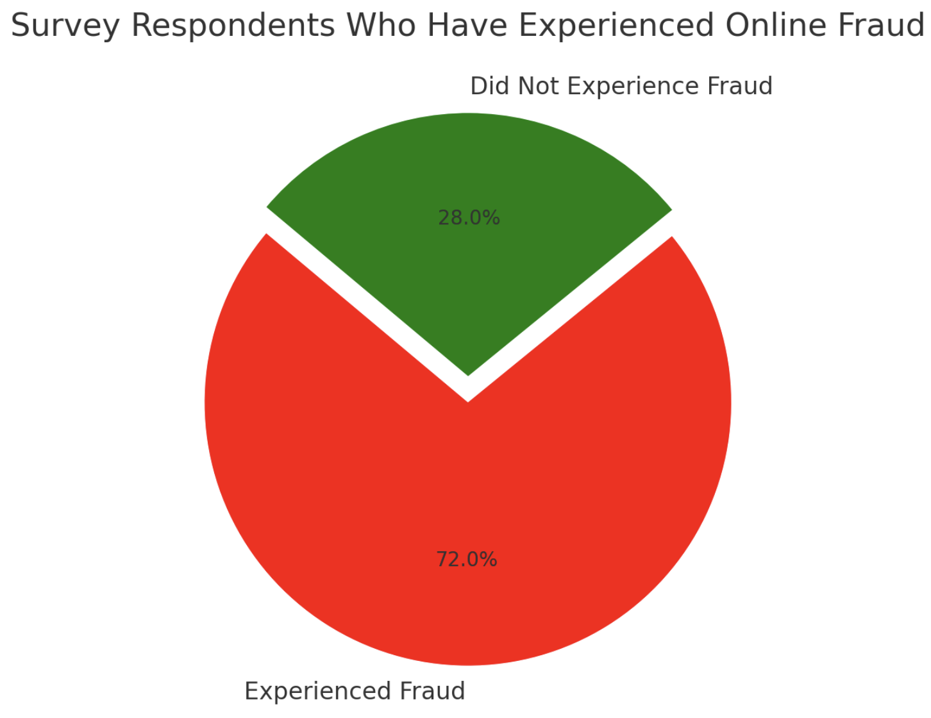
Figure 2. Respondents who have experienced online fraud
The interview notes were reviewed to extract common themes or notable quotes that exemplify user needs and concerns. Below are the key findings from the analysis, categorized by theme, along with interpretations and their implications for system design:
- Trust and Adoption Concerns: A significant majority of participants expressed concerns about trust in online transactions. In the survey, 72% of respondents indicated they (or someone they know) have been scammed or defrauded when buying or selling online. This high figure underscores that fraud is a common experience, underscoring the need for a solution like Tredit. Furthermore, 85% responded that they would be likely or very likely to use an escrow service to secure their transactions if one were available. Interviews reinforced this: one buyer stated “I only buy from people I’ve met or who have a shop, otherwise I fear losing money.” This indicates that lack of trust is limiting e-commerce growth. However, awareness of blockchain is relatively low – only about 20% of survey respondents felt they understand how blockchain or cryptocurrencies work. Others were either vaguely familiar or not at all. Despite this, many respondents did not object to the use of blockchain if it was “behind the scenes.” In fact, a common sentiment was that simplicity and guarantees matter more than the underlying tech. Implication: The platform’s core value proposition (escrow for trust) is highly relevant and in demand. The design should emphasize security and fraud prevention, but it must also abstract the blockchain complexity for average users. Building trust will also involve incorporating visible safeguards (like verified seller badges or escrow status updates) to reassure users at each step.
- Feature Priorities: The analysis of feature preference questions revealed which functionalities users consider most critical in an escrow e-commerce platform. The most highly requested feature was a robust dispute resolution mechanism: about 60% of respondents ranked “dispute resolution/mediation” as a top-three essential feature. This indicates that users not only want funds held, but also a fair way to resolve issues if something goes wrong (item not delivered, item not as described, etc.). The second-highest priority was payment/delivery tracking notifications – Fifty-five percent (55%) of respondents want to receive real-time updates, such as confirmation when payment is secured in escrow, when the seller ships the product, and reminders to confirm delivery. The next important feature cluster was ratings and reviews: around 45% indicated that having buyer/seller ratings or a profile reputation system would increase their trust in using the platform (this was frequently mentioned in interviews as well, e.g., “I’d trust more if I saw others have successfully dealt with this seller.”). Some other features like social media account verification for sellers and an escrow fee calculator were noted but were lower priority compared to the above. On the other hand, complex blockchain-specific features (like viewing the raw transaction on a blockchain explorer) were rated as least important by most users; only a few tech-savvy respondents cared to have that transparency, while others said they prefer the system just tells them the status in simple terms. Implication: The system’s functional requirements must center on the top-priority features. This means implementing a clear dispute resolution process is a must (e.g., allowing users to raise disputes, submit evidence, and have an admin or arbitrator make a decision). Likewise, a notification subsystem should be in place for key events (escrow funded, item shipped, etc., possibly via SMS/email given user preferences). A ratings/review system or at least a way to see a user’s successful trades history should be planned to foster trust between users. Lower-priority or more advanced features (like blockchain transaction views or optional integrations) can be considered for later versions or as secondary features to include if time permits, but they should not clutter the initial user experience.
- Payment and Cost Expectations: The feedback illuminated user expectations regarding payments on the platform and cost considerations. Importantly, 67% of users indicated a strong preference for using familiar payment methods (such as mobile money M-Pesa, bank cards, or cash-on-delivery) over direct cryptocurrency payments. This is not surprising given the Kenyan market’s heavy use of M-Pesa for digital payments. However, when it was explained that the escrow would internally use blockchain, many respondents were amenable as long as “I can pay in Kenya Shillings and it (the system) handles the rest.” This suggests that users are open to the technology if the interface accepts their usual currency and method. On costs, users expect escrow fees to be minimal – about 50% stated they would only use the service if the fee was less than 5% of the transaction, and 25% said less than 2%. A handful (15%) were willing to pay higher for very secure transactions (like high-value items), but generally cost sensitivity is high. Additionally, interviewees highlighted the importance of fast transactions: buyers don’t want to wait too long for confirmation that payment is secured or for release once they confirm receipt. They are used to near-instant mobile money transfers; one seller said “If it takes hours to confirm payment, customers will complain.” In survey terms, 90% of respondents expected the payment escrow confirmation to happen within 5 minutes or less. Implication: These findings affect both design and potential integrations. The system should interface with local payment gateways – for instance, allowing a user to deposit into the escrow via M-Pesa or card, which then gets converted to the on-chain escrow (this could be implemented via an off-chain wallet service or a payment processing partner). Even if the backend uses crypto, the front-end should present values in KES (Kenyan Shillings) for familiarity and clarity. Keeping costs low is crucial: by using Polygon, we have addressed the technical cost per transaction; however, any added escrow fee on top must be very nominal. The design might include a transparent fee breakdown before user confirms a transaction, so they know the cost upfront. Ensuring transactions are fast and efficient will require optimizations like pre-funding the contract or using reliable nodes – essentially, the user experience should feel real-time. Any delay (e.g., waiting for block confirmations) should be communicated with progress indicators to manage expectations. Ultimately, aligning with user payment habits (maybe phasing in crypto slowly, or abstracting it entirely in the UX) and meeting cost and speed expectations will be key to user adoption and satisfaction.
- Usability and Accessibility: The analysis also provided insight into how the platform should be designed from a usability perspective. A large portion of respondents (around 80%) stated they primarily use smartphones for their online activities, rather than desktops. Moreover, 70% indicated they would prefer an app or a mobile-optimized website for using the escrow service. This highlights the need for a responsive design that works well on mobile screens and possibly a dedicated mobile application. In terms of interface design, users voiced that simplicity and guidance are important. On a Likert scale question, 88% agreed that “If the process is too complicated, I might not use the service.” Qualitative feedback from the survey’s open-ended section and interviews echoed this: terms like “blockchain” or “crypto” can be intimidating; one participant suggested “Just say the money is held safely – you don’t need to mention how, unless someone wants details.” There was also interest in language support: a few respondents noted that having the option to view the interface in Swahili would be helpful for those less comfortable with English, even though many are bilingual. Additionally, trust signals in the UI were mentioned – for example, showing that a transaction is “100% secured by escrow” or showing partner logos (if any) to make it feel legitimate. On accessibility, participants appreciated the idea of being able to reach customer support easily; over 50% said they’d like a “Help” or chat feature in case they have questions during a transaction. Implication: The UI/UX design must prioritize clean, simple, and mobile-first design. Key actions (like starting an escrow, confirming delivery) should be very straightforward with clear buttons and instructions. Technical jargon will be avoided in the user-facing text; instead, use friendly language (e.g., “Your payment is now locked safely with Tredit” rather than “Funds transferred to smart contract”). A bilingual interface option (English/Swahili) is recommended, or at least using easily understandable icons and graphics to aid comprehension. The design can incorporate visual cues to build trust – for instance, a lock icon or shield icon when funds are in escrow, and a checkmark when a step is completed. Given the mobile preference, all pages and forms should be tested on typical smartphone screen sizes to ensure readability and ease of use (for example, large buttons, minimal text input where possible). A quick tutorial or tooltips for first-time users might also ease the onboarding process (perhaps a short walkthrough when a user first initiates an escrow). Lastly, including a visible help channel (like a chat widget or a prominent help center link) will address user anxiety and help them resolve any confusion promptly, thereby improving the overall usability and user confidence in the system.
Overall, the data analysis confirms that users are enthusiastic about the concept of a secure escrow platform and have clearly identified needs and expectations that the system must meet. The findings directly inform the formulation of the system’s requirements (both functional and non-functional) in the next section. They ensure that the design of Tredit is grounded in real user input – focusing on building trust, incorporating essential features like dispute resolution, accommodating local payment habits, and delivering an intuitive user experience. By reflecting on these insights, the project can prioritize development effort on the features and qualities that matter most to its intended users, thereby significantly increasing the likelihood of the platform’s success and adoption.
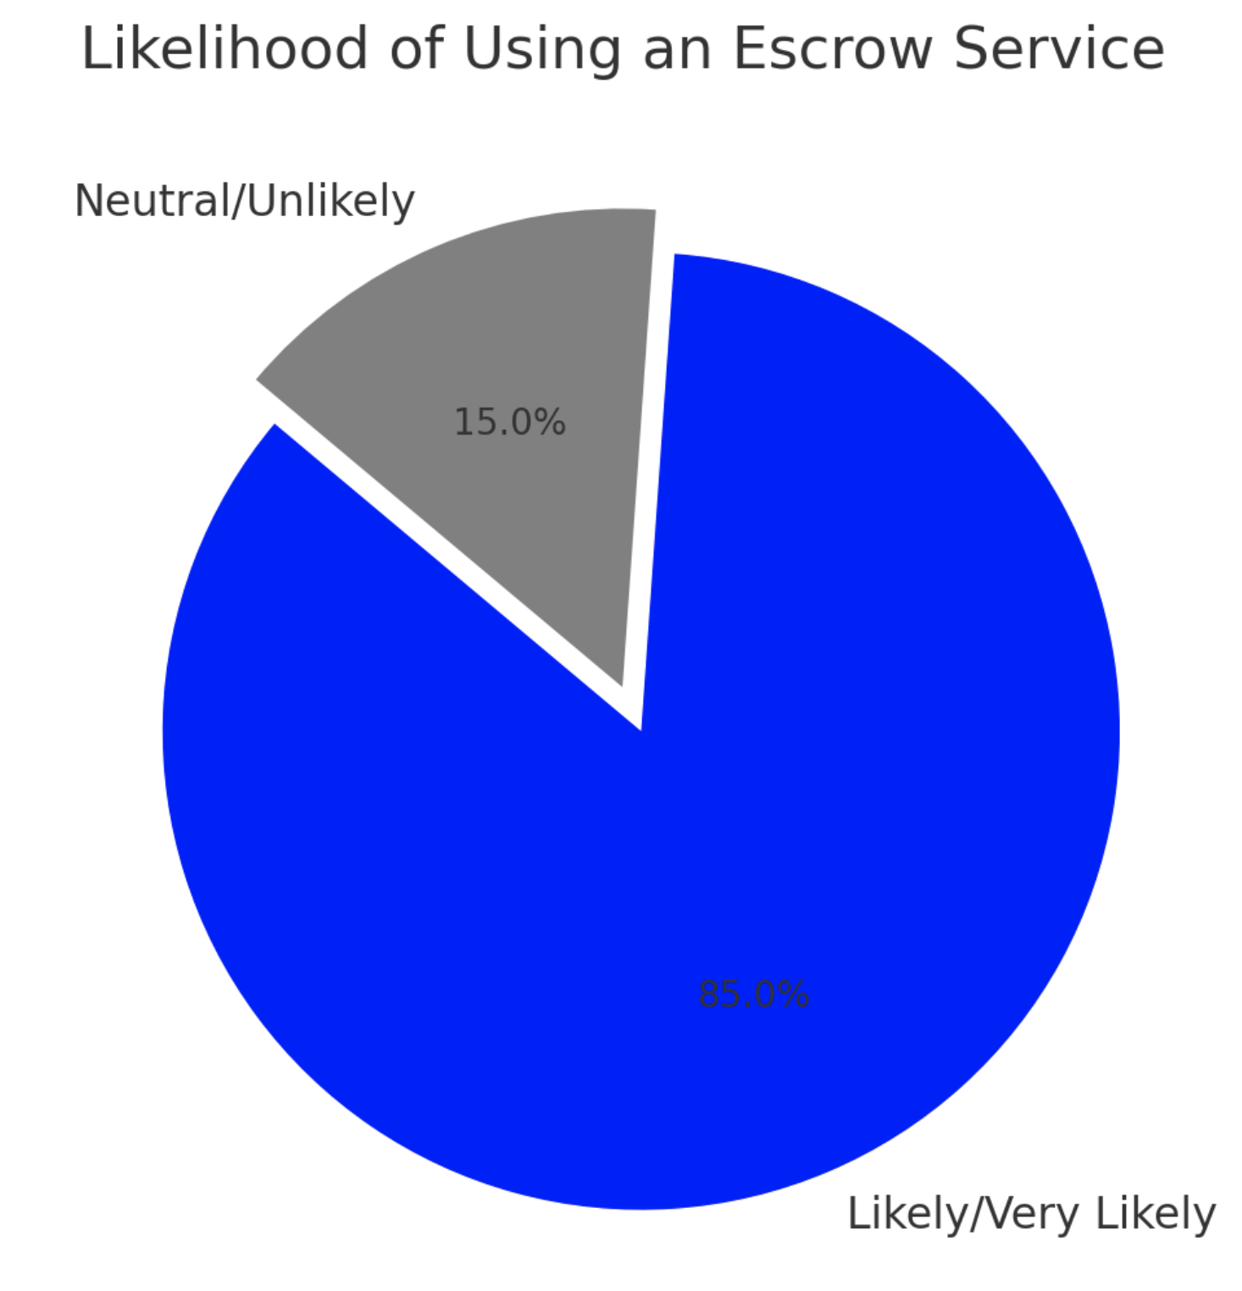
Figure 3- Likelihood of using escrow

3.6 System Specification
Based on the elicited requirements and analysis, a detailed specification of what the Tredit system must do was developed. This includes functional requirements, describing the specific functionality and services the system will provide, and non-functional requirements, describing the quality attributes, constraints, and other characteristics the system must have. All requirements have been documented to align with user needs and project objectives, serving as a blueprint for design and implementation.

Functional Requirements
The functional requirements define the core operations of the Tredit platform – essentially, the capabilities the system must offer to fulfill its intended purpose as a blockchain escrow e-commerce solution. Each requirement below is derived from the use case analysis of buyer, seller, and administrator interactions:
- User Registration and Authentication: The system shall allow new users to register for an account. Registration includes capturing essential details (e.g., name, email, phone number, wallet address) from google OAuth and verifying contact information.
- User Profile Management: Users shall be able to manage their profile information. This includes updating personal details (email, phone, delivery address, etc.), managing their linked payment methods or wallet, and viewing their own trust indicators (such as their transaction completion rate or ratings). All changes to profile or settings should be securely saved and reflected immediately.
- Product Listing Management (Seller): The system shall enable seller users to create and manage product or service listings. A listing includes details such as title, description, price (in KES, with system converting or referencing underlying crypto value as needed), category, and one or more photos. When a listing is created, the system will store the textual information in the database and upload any images or files to IPFS (returning content hashes). Sellers can edit or delete their active listings. Each listing has a visible status (e.g., “Available”, “Pending Sale”, “Sold”) based on whether it’s currently involved in an ongoing transaction.
- Product Browsing and Search (Buyer): The system shall provide a marketplace interface where buyers can browse available listings. Buyers can search for listings by keyword, filter by category or price range, and sort results (e.g., by date or price). For each listed item, the buyer can view a detailed page showing the full description, images (fetched from IPFS via their hashes), the seller’s information (including their rating or verification status), and the price. This interface is the storefront of Tredit, facilitating discovery of items.
- Initiate Purchase with Escrow: When a buyer decides to purchase an item, the system shall guide them through initiating an escrow-protected transaction. This involves the buyer clicking “Buy” or “Initiate Trade” on a listing, which triggers an order creation. The system will generate a unique escrow smart contract instance or use a smart contract function call for that transaction. The buyer is prompted to make the payment into the escrow – if paying via the integrated crypto wallet, the system will invoke the Polygon blockchain transaction for the specified amount (e.g., in MATIC equivalent to the price). If paying via a fiat gateway (e.g., M-Pesa), the system will coordinate receiving fiat and locking a corresponding on-chain amount via an off-chain service. At this point, the order record is created in the database linking buyer, seller, and listing, and marked as “Payment Pending” or “In Escrow” once payment is confirmed. Funds are now held in escrow (in the smart contract) and neither party can access them except by the contract’s rules.
- Order Status Tracking: The system shall provide both buyer and seller with real-time updates on the status of the transaction. After payment is secured, the order status updates to “Payment Secured” and the seller is notified to proceed with delivery. The seller can update the order by marking the item as shipped and possibly providing tracking information (if applicable). The buyer can see these updates (e.g., “Shipped on [date], tracking number XYZ”). All status changes trigger notifications to the relevant party (and appear on their dashboard). The buyer’s dashboard will list active purchases and their current stage (Awaiting shipment, Shipped, etc.), and similarly, the seller’s dashboard lists their active sales.
- Delivery Confirmation (Release Escrow): Once the buyer receives the product, they will confirm delivery. The system shall allow the buyer to mark the transaction as “Item Received – Satisfied” which effectively instructs the escrow smart contract to release the funds to the seller. Technically, if the buyer clicks a “Confirm Receipt” button, the system will prompt a blockchain transaction (if needed, or this could be triggered through a backend service with buyer’s authorization using a unique key generated when the product was shipped) that releases the held funds from the escrow to the seller’s wallet address. The order status then becomes “Completed,” and both parties are notified that the transaction finalized successfully. The seller’s balance (if within the platform) is updated to reflect the incoming funds or, if the contract directly pays out, the seller will simply see confirmation of payment.
- Dispute Resolution Process: If the buyer is not satisfied (for example, the item was not delivered or is not as described), the system shall support a dispute mechanism. The buyer can flag the order as “Raise Dispute” instead of confirming receipt. This will halt automatic funds release (the escrow contract can be designed to wait for an admin decision in this case). The system then allows both parties to submit input: the buyer can provide a description of the issue and upload evidence (photos, cart metadata, including chat messages, etc.), and the seller can respond with their perspective or proof (like shipment receipts). An administrator or arbitrator user will be notified of the dispute and will review the case. The admin will have privileged capabilities to resolve the dispute in the system. Once a decision is made (e.g., refund buyer or release payment to seller, or a compromise), the admin can trigger the appropriate outcome. For example, the admin can call a function on the escrow contract to release funds to the chosen party or split as needed (this requires that the smart contract was designed with an admin key or multi-signature mechanism for arbitration). The system then updates order status to “Dispute Resolved – Refunded” or “Dispute Resolved – Completed” accordingly, and notifies both parties of the resolution outcome. All disputes and resolutions should be logged for accountability.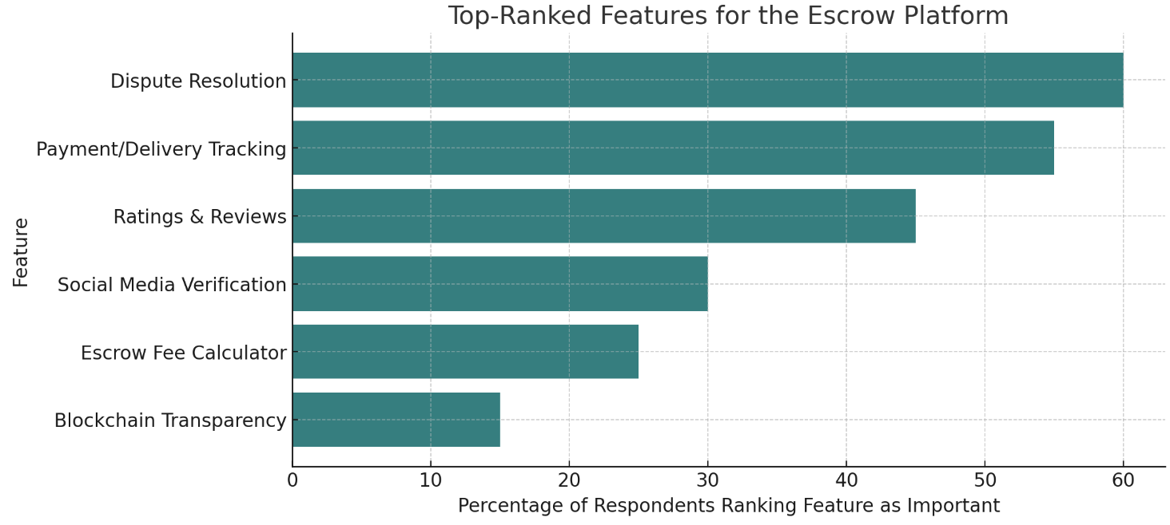
Figure 4-Features

Non-Functional Requirements

In addition to the functional capabilities, Tredit must meet several non-functional requirements that describe the quality attributes of the system. These are critical for user satisfaction and system sustainability. The non-functional requirements include:
- Security: The system must ensure a high level of security since it deals with financial transactions and personal data. All communication between clients and the server will use HTTPS with TLS encryption to prevent eavesdropping. Sensitive data (passwords, private keys if any, personal IDs) will be stored securely – for example, passwords hashed with a strong algorithm, and any private keys encrypted or preferably avoided (the platform will encourage users to use their own wallets so it doesn’t handle private keys). The smart contract code must be free from known vulnerabilities (reentrancy, overflow, etc.), achieved by following Solidity best practices and possibly undergoing a code review/audit. Role-based access control will be enforced: regular users cannot perform admin functions, and admin actions on the blockchain (like dispute resolution) might require a secure multi-signature or hardware wallet by the admin to execute, adding an extra layer of security for administrative keys
- Performance and Scalability: The platform should be responsive and capable of handling increasing load as more users join. Performance requirements include pages loading within a few seconds on typical connections, and search queries executing quickly. The escrow transaction confirmation should occur as fast as the blockchain allows (typically within a minute on Polygon); the system will not introduce significant overhead beyond that. On the server side, the architecture (detailed in Section 3.8.1) will separate concerns to optimize performance – for instance, heavy tasks like image storage are offloaded to IPFS to reduce server load
- Usability: Given the target user base includes non-technical individuals, the system must be easy to use and navigate. This involves a clean and intuitive user interface design (as elaborated in Section 3.9.2) with logical workflows. The language used in the UI will be clear and free of unnecessary technical jargon. For example, users will see labels like “In Escrow” rather than “Locked in Smart Contract”. The system will provide guidance where needed; tooltips or a help icon can explain unfamiliar concepts (like what “escrow” means). Consistency in design (uniform color scheme, buttons performing expected actions) will help users build familiarity quickly. The platform will be mobile-responsive and tested on various devices to ensure the layout and functionality remain user-friendly on small screens
- Reliability and Availability: The system should be reliable, minimizing downtime or errors, as users will depend on it for important transactions. Reliability will be achieved through robust design and testing. Key functions like transaction processing will have error-handling and fallback procedures. For instance, if a blockchain transaction fails due to network issues, the system will detect the failure and inform the user with an option to retry, rather than silently dropping the operation. The state of the escrow (whether payment is locked or not) will be verified by querying the blockchain directly to avoid inconsistencies
- Compliance and Legal Requirements: The design must ensure compliance with data protection and any other regulatory requirements. Non-functionally, this means building in features like data privacy controls – e.g., allowing a user to request their account deletion (which the system will handle by anonymizing personal data while retaining transaction records that may be needed for audit). It also means the system should have a clear audit trail for financial transactions for accountability (useful in case of legal disputes or audits). Terms and Conditions and a Privacy Policy will be easily accessible, and users must agree to them.

3.7 Requirements Analysis and Modelling
To further refine the requirements and ensure a clear understanding of the system’s behavior, several modeling techniques were employed. Models such as use case diagrams and data flow diagrams (DFDs) provide visual representations of system interactions and data movements. These models help in validating the requirements (by showing how actors will use the system and how information flows) and in identifying any dependencies or conflicts among requirements. This section describes the key models created and discusses requirement dependencies and potential conflicts that were analyzed, along with how any conflicts were resolved.
Use Case Diagram: A use case diagram was developed to illustrate the interactions between various user roles (actors) and the system’s use cases (functionalities). The main actors identified are:
- Buyer: An end-user who purchases goods/services on the platform.
- Seller: An end-user who lists and sells goods/services on the platform.
- Administrator: A user with special privileges who manages the system and resolves disputes.
Each actor is associated with relevant use cases. For example, the Buyer actor has use cases like “Register/Login,” “Browse Listings,” “Initiate Purchase (Escrow Payment),” “Confirm Delivery,” and “Raise Dispute.” The Seller actor has use cases “Register/Login” (common to all users), “Create Listing,” “Manage Listing” (edit or remove), “View Orders” (to see incoming orders), and “Ship Item/Provide Delivery Info.” The Administrator actor has use cases such as “Review Dispute” and “Manage Platform” (which covers user management and oversight of listings/transactions).
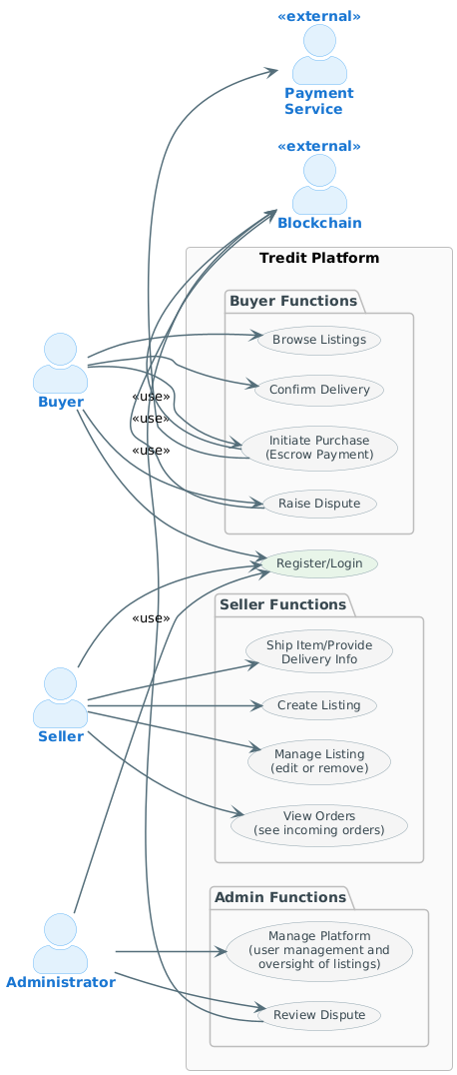
Figure 5 - Use Case Diagram
Data Flow Diagrams (DFDs): To understand how data moves through the system and to validate the correctness of process logic, Data Flow Diagrams were created at multiple levels of detail. A Context-Level DFD (Level 0) was first drawn to show the system (Tredit) as a single process and its interactions with external entities: Buyers, Sellers, Admin, and external payment/blockchain services. In this context diagram, data flows such as “Order Details,” “Payment Information,” “Confirmation/Notification,” and “Dispute Report” are depicted between the system and these entities. This helped affirm that all necessary external interactions (like receiving payment confirmation from the blockchain network, or sending notifications via email gateway) were accounted for. Next, a Level 1 DFD was created to break down the system into major processes (e.g., User Management, Listing Management, Transaction/Escrow Process, and Dispute Handling) and show data stores (like the User Database, Listing Database, etc.). For example, the Transaction Process DFD details the steps when a buyer initiates a purchase: the buyer provides order request data, which goes into a “Create Order” process; this process interacts with a “Payment Processing” sub-process (which in turn connects to the blockchain service, indicating data like transaction ID and payment status flows back). The data store “Order DB” is updated with the new order and its escrow status.
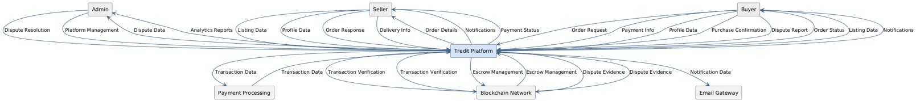
Figure 6 - DFD Level 0

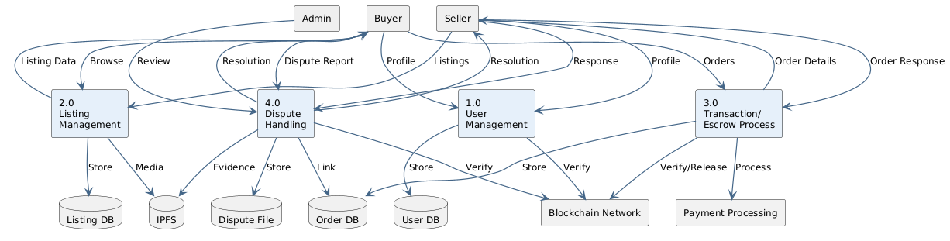
Figure 7 - DFD Level 1

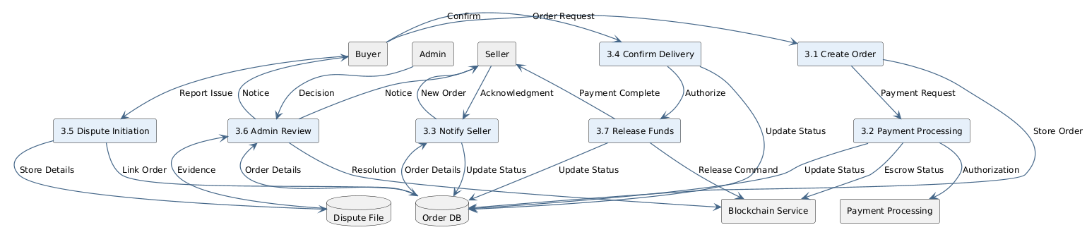
Figure 8 - Transaction Process DFD
Dependencies: In analyzing the requirements and models, several dependencies between requirements became apparent:
- Functional dependencies: Some features depend on others to function correctly. For example, escrow payment release depends on delivery confirmation – i.e., the requirement “release funds to seller” is triggered only after the requirement “buyer confirms delivery” is fulfilled. This dependency was modeled in the activity flow and ensures that any design must enforce the sequence (it would be a serious flaw to allow funds release without confirmation or dispute resolution).
- Data dependencies: The dispute resolution process depends on data from the transaction (order details, evidence). Thus, the quality of the dispute outcome relies on the system having captured all necessary information during the transaction (e.g., it’s important that the system logs what item was expected, what was delivered, timestamps, etc., so the admin has full context).
- Module dependencies: The notification functionality depends on other events (it has no purpose on its own; it triggers on events like order creation, shipment, etc.). So, notifications are secondary and require the core processes to supply triggers.
- External dependencies: The system relies on external components such as the Polygon blockchain network and IPFS network. This means that requirements involving transactions and file storage depend on the availability and correctness of those external services. For instance, if the Polygon network is down or congested, the escrow funding might be delayed. Recognizing this, a non-functional requirement for reliability is to perhaps queue transactions or inform users in case of such external slowdowns.
- Sequence dependencies: The use cases have an inherent sequence (you must register before you can create a listing; a listing must exist before a purchase; a purchase must happen before a dispute on that purchase, etc.). These were noted to ensure the UI and system enforce the proper workflow (e.g., a seller can’t ship an item unless an order exists for it; the system will only present the “Ship Item” option after an order is placed).
Understanding these dependencies allowed in scheduling development in a logical order as well (Agile sprints can be arranged to build foundational features first, like listing and order creation, then escrow, then dispute handling, etc., respecting dependencies). It also ensures in design that modules that depend on each other have well-defined interfaces.
Potential Conflicts: During requirements analysis, we also identified a few potential conflicts or trade-offs between requirements:
- Transparency vs. Privacy: One conflict arises from the desire to leverage blockchain transparency (which would imply making transaction data public for verification) versus the need to protect user privacy (personal details should not be exposed on a public ledger). The requirement for transparency (users being able to verify escrow transactions) conflicts with data privacy (keeping identities confidential).
- Security vs. Usability: Another classic conflict is between security and ease-of-use. For instance, a highly secure system might require complex user verification or multiple authentication steps (multi-factor auth, signing transactions in a crypto wallet) which could make the user experience cumbersome, clashing with the requirement for a smooth and simple UX for non-technical users.
- Immutability vs. Dispute Resolution Flexibility: Blockchain transactions are immutable and smart contracts execute code exactly as written. However, the system requirement for dispute resolution means there must be some flexibility to override or redirect a payment after the fact if a dispute is resolved in favor of the buyer. There is a conflict in that blockchain by default doesn’t allow reversing transactions. The design of the escrow contract must reconcile this by building in an exception path for disputes, which if not done carefully could conflict with the security (it introduces an admin key that must be secured).
- Performance vs. Cost: We want the system to be fast (performance), but using a blockchain can introduce latency and each on-chain interaction has a cost. To keep costs low (for economic feasibility), one might limit the number of on-chain operations, but that could conflict with giving real-time detailed updates (performance/feature richness). We had to find a balance, perhaps by batching certain operations or utilizing off-chain signaling for non-critical updates.
- Feature Creep vs. Simplicity: Stakeholders indicated a variety of desired features (escrow, tracking, chat, reviews, etc.). Trying to implement all features extensively could conflict with the objective of having a simple, clean system initially. There was a need to prioritize (as seen in data analysis) and possibly defer lower-priority features to avoid over-complicating the MVP (minimum viable product).
Resolution of Conflicts: Each identified conflict was carefully addressed through design decisions:
- For transparency vs privacy, the solution is to store sensitive personal data off-chain and only keep necessary transaction references on-chain. For example, the smart contract might record that Order #123 has X amount in escrow and is between BuyerID 7 and SellerID 3 (or just their wallet addresses), but it won’t contain personal info like names or item details. The detailed info remains in the off-chain database, protected by our privacy measures. Thus, one can verify on-chain that escrow happened and was released, but they cannot glean personal identities from the blockchain. This hybrid approach satisfies transparency (financial transactions can be audited on-chain) while preserving user privacy (personal data is kept off-chain in compliance with data protection).
- In the security vs usability trade-off, MetaMask handles the cryptographic signing before authentication for login. Additionally, using familiar OAuth login for identity and then separately handling the funds via blockchain helps; the user doesn’t have two completely separate login processes. By smoothing these edges and providing clear guidance.
- To solve immutability vs dispute flexibility, the design of the escrow smart contract includes an “arbiter” role (the platform’s admin key). The contract will have logic such that funds can only be released in one of two ways: (a) automatically to seller when buyer and seller both signal completion (buyer confirms delivery), or (b) to either party based on an admin’s decision in case of dispute. This means the contract holds funds until it receives a signed instruction from the admin (in a dispute scenario) or the buyer’s confirmation (in a happy path scenario).
- For the performance vs cost issue, the solution lies in optimizing on-chain interactions. We decided that not every single update would be an on-chain event.

3.8 Logical Design
Logical design involves conceptualizing the solution structure and behavior without getting tied to specific technologies or physical constraints. In this section, we present the high-level architecture of the system, the design of key processes through flow design (like activity and sequence diagrams), and how the design addresses the non-functional requirements identified earlier. This provides a blueprint for how the system will operate in theory, setting the stage for the concrete physical design and implementation.

3.8.1 System Architecture
Architecture Pattern: The Tredit platform is designed using a layered 3-tier architecture, which is a client-server model separating the system into Presentation, Application, and Data layers. This separation of concerns enhances modularity, scalability, and maintainability.
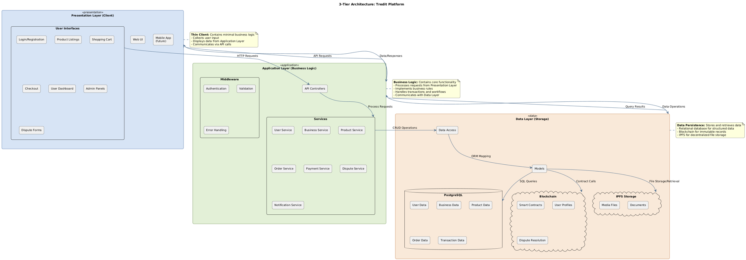
Figure 9 - 3 tier architecture
- Presentation Layer (Client): This is the user interface of the system that end-users (buyers, sellers, admins) interact with. In Tredit’s case, the presentation layer is primarily a web application (which could be accessed via browsers on desktops or smartphones) and potentially a dedicated mobile app in the future.
- Application Layer (Server / Business Logic): The application layer contains the business logic of Tredit. It acts as an intermediary between the presentation layer and the data/storage components (database, blockchain, IPFS). This layer is implemented on a backend server (or a set of microservices). Key responsibilities of the application layer include: managing user sessions and authentication, enforcing business rules (e.g., one cannot purchase their own listing, or an escrow cannot be initiated if the item is already sold), orchestrating transactions (coordinating between the database and blockchain calls), and processing inputs to produce the appropriate outputs.
- Data Layer (Data Storage and Blockchain): The data layer comprises all data storage and retrieval systems – this includes the relational database, the blockchain ledger, and IPFS storage. In the Tredit architecture, this layer is somewhat distributed:
  - The Relational Database (PostgreSQL) stores structured data required by the platform off-chain: user profiles, product listings, order records, dispute records, reviews, etc. It maintains relationships between these entities (as described in the database design section) and allows querying them efficiently. This database ensures that we can quickly fetch and update application state without relying on the slower blockchain for everything. For example, listing details and user credentials reside here.
  - The Blockchain (Polygon) acts as a transactional data store for the escrow funds and the state of those funds (locked or released). The smart contract deployed on Polygon holds the logic and data about each escrow transaction (like mapping of escrow ID to amounts and addresses, and statuses). The blockchain is effectively a secure, append-only database for financial transactions and certain immutable records.
  - IPFS (InterPlanetary File System) provides decentralized file storage for larger or unstructured data, such as images of products or any documents (perhaps dispute evidence files). Instead of storing these in a centralized server or in the database (which is not efficient for large binaries), the files are added to IPFS. IPFS returns a content hash (CID) which we then store in the database (in the product or dispute record). When a user needs to view the image, the application retrieves it from IPFS (via an IPFS gateway URL or direct IPFS node fetch). IPFS ensures that files are content-addressed and distributed; even if our server or one node is down, the content can be retrieved from the network of peers.
3.8.2 Control Flow and Process Design
To ensure that the system’s dynamic behavior is well thought out, UML diagrams such as activity diagrams and sequence diagrams for key processes are designed. These diagrams depict the flow of control and messages between components in various scenarios, helping to validate logic and identify any potential issues in process execution order or responsibility.
Activity Diagram – Escrow Transaction Workflow: One of the most important processes is the end-to-end workflow of a purchase protected by escrow. An activity diagram was created to map this process from start to finish, including different paths (normal vs. dispute).
This activity diagram ensures that we have covered all steps and responsibilities. It clearly shows how control passes from user to system to user, and where concurrency or waiting occurs. By having this, developers can implement each step knowing what comes before and after. It also highlights points of integration (for example, the “Release payment” step is where the system interacts with blockchain, and that is shown as a distinct action). The diagram was reviewed to confirm it aligns with the requirements: for instance, it explicitly includes the dispute branch, satisfying that requirement; it includes notifications as part of actions; and it shows termination conditions. Any ambiguities (like what if buyer forgets to confirm?) can be noted with annotations (like a time-out after which perhaps auto-release occurs if no dispute; though that rule would be specified as a business rule if needed).
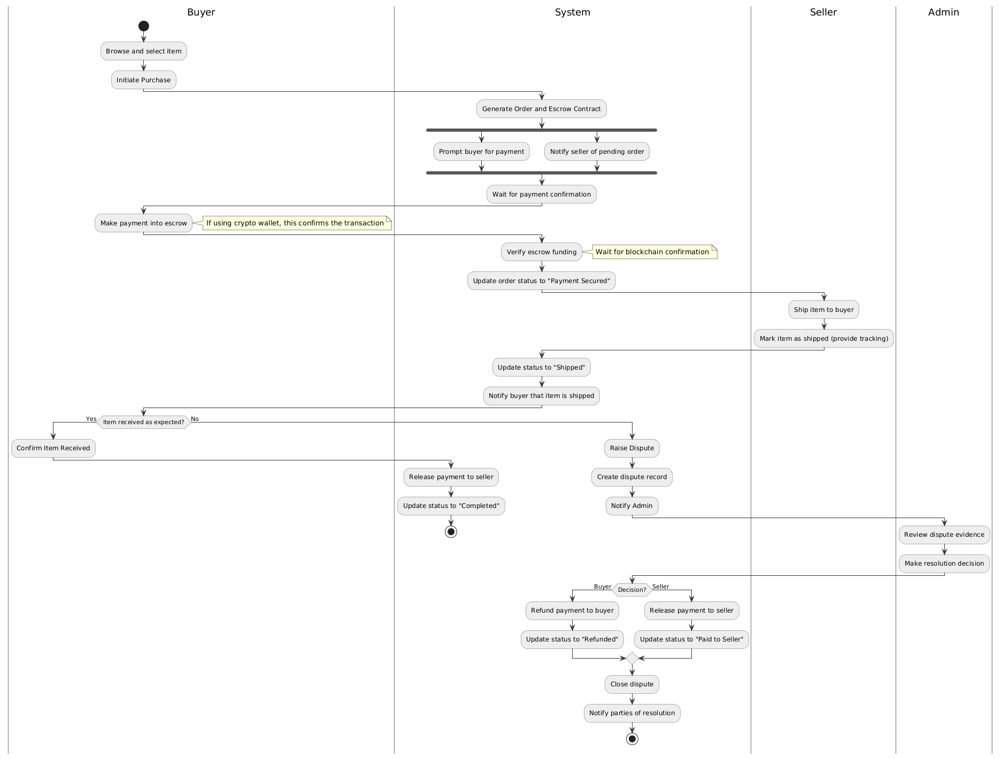
Figure 10 - Activity Diagram

Sequence Diagram – System Interaction in Purchase: While the activity diagram shows the high-level flow, a sequence diagram provides a more technical view of how different components of the system interact in a specific scenario. The Buyer (browser/client) sends a “Purchase Item” request (e.g., clicking the button triggers a REST API call) to the Web Server.
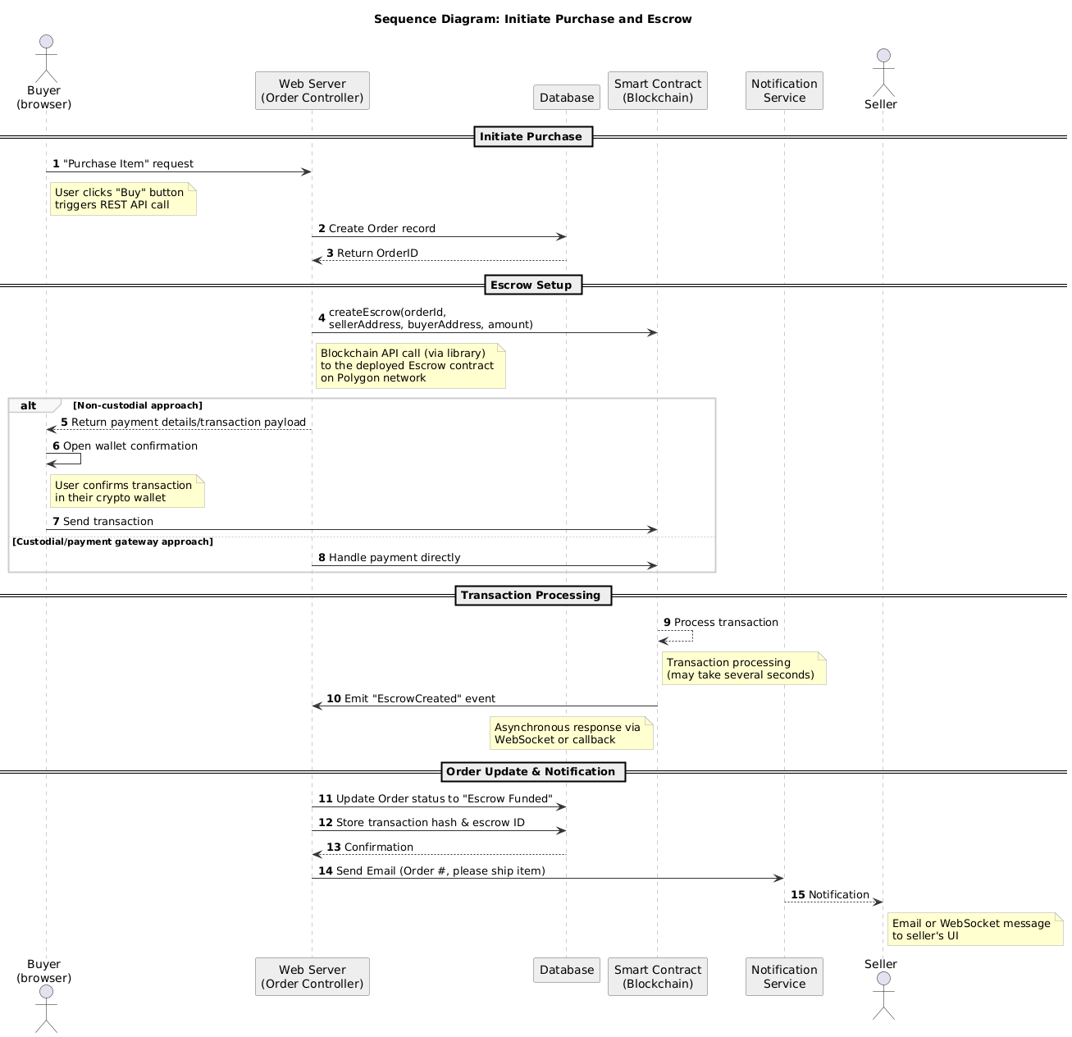
Figure 11 - Sequence Diagram

3.8.3 Design for Non-Functional Requirements
The logical design also explicitly considers how the system’s architecture and processes fulfill the non-functional requirements discussed in Section 3.6. Here we highlight how our design choices address key non-functional areas:
- Security by Design: Security was built into the design at multiple levels. Architecturally, the separation of concerns means the database and application server can be placed behind secure firewalls, and only the presentation layer (web client) is exposed to the internet. Communication channels are secured (the design assumes HTTPS for client-server API calls and WSS for any real-time notifications).
- Performance and Scalability: The logical design’s modular architecture facilitates performance optimization and scaling. For example, since the application layer is stateless (the sequence diagrams show that after processing a request, the server can forget about it, storing necessary state in the database or relying on the blockchain events), we can run multiple server instances to handle more load without conflicts. The choice of using IPFS and off-chain storage for heavy content means our core system deals mostly with lightweight data (text, numbers) and can serve those quickly from the database.
- Usability and Accessibility: Many design choices were made to maximize usability. For instance, the use case flows are designed to minimize the number of steps a user has to take: our activity diagram merges some steps (like order creation and escrow funding happen in one flow from the user’s perspective, even if behind the scenes it’s multi-step

3.9 Physical Design
Physical design takes the logical models and adapts them to specific technologies and concrete specifications that will be used in implementation. It deals with how data is physically stored in databases, how the user interface is concretely laid out, and other implementation-level details. In this chapter section, we detail the physical database design and the user interface design for Tredit, including the structure of tables, relationships, and examples of input/output layouts (with wireframe placeholders). This forms the blueprint for actual coding and deployment.
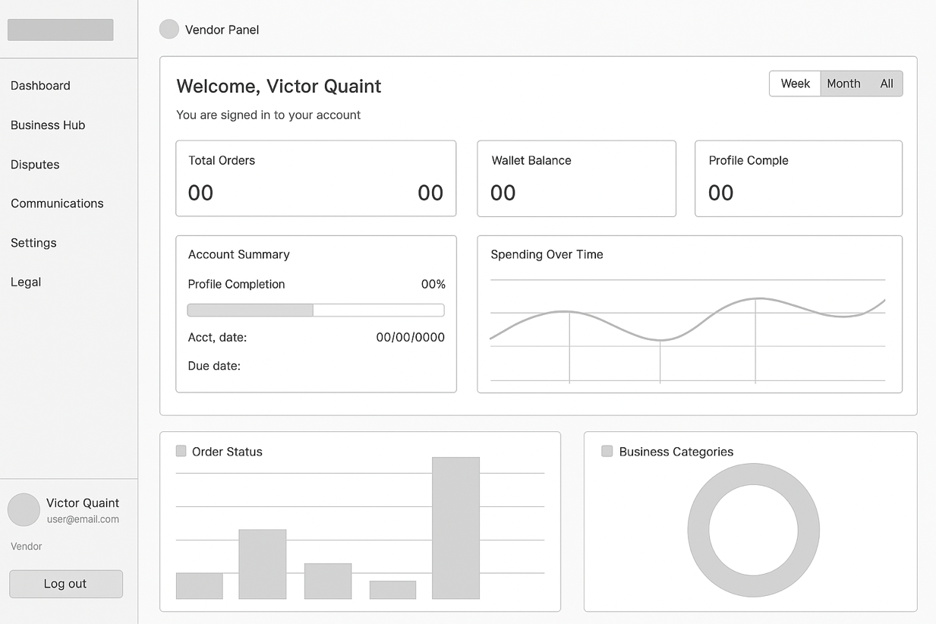
Figure 12 - Wireframe

3.9.1 Database Design
The database for Tredit is implemented as a relational database (PostgreSQL), chosen for its ability to enforce structure and relationships among data which is crucial for an e-commerce platform. The schema design follows from the data model outlined in analysis, with an emphasis on normalization (to at least Third Normal Form) to minimize redundancy and ensure data integrity. Below we describe the main tables and their relationships in the database.
- Users Table: This table stores user account information for all platform users (buyers, sellers, and admins – a role field can distinguish them). Each user can have many businesses which have listings and many orders (in different roles), hence relations: One-to-many from Users to businesses (a user may be a team member of many businesses), and one-to-many from Users to Orders (a user can be buyer in many orders, and also one-to-many as seller via listings). We may also have a separate table for admin actions but that can be logged in an Audit table.
- Business Table: Stores details of user’s businesses which can have items/products or services listed for sale. Each business can have many team members (many-to-many to Users). Each business can have many orders over time (if multiple quantities or relisted), but typically one business corresponds to one sale.
- Orders Table: This is central to tracking transactions/escrow. Relationships: Orders table links to Users (Buyer and Seller) and to Business. It may also link to a Dispute table if disputes are elaborated in another table. One user can have many orders as buyer and many as seller. One business might have many orders.
- Disputes Table (optional): To capture details of disputes. This table helps keep track of disputes separately and can be extended if we incorporate an external arbitration (like Kleros or so) in future. Relationship: one dispute belongs to one order; an order could have at most one dispute.
This schema ensures that all necessary data for the platform is properly organized. Normalization: Data is separated into tables to avoid redundancy – e.g., user info in Users, not duplicated elsewhere; product info in Listings separate from Orders. The database design was verified in terms of normalization: for instance, Listings and Orders have a one-to-many; if we had stored all listing details in Orders, that would be redundant and not normalized. Instead, we reference listing. Similarly, we don’t duplicate user info in order beyond IDs. Some redundancy (like copying price) is acceptable for audit trail logic.

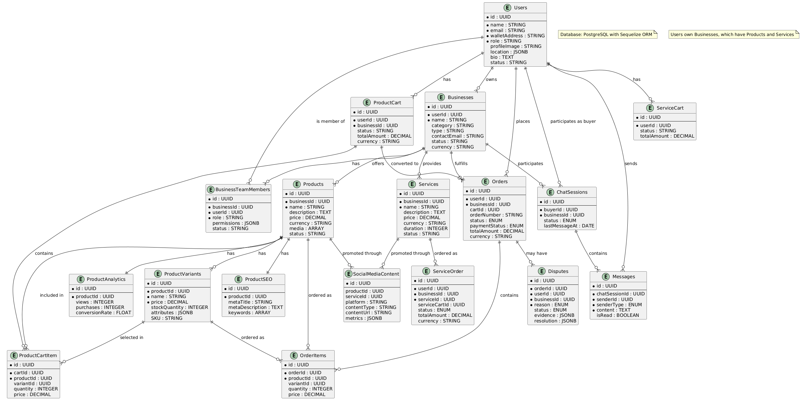
Figure 13 - Database Schema
Relationships and Constraints:
- Users–Business: one user (seller) to many Businesses. Enforce via foreign key Business.SellerID -> Users.UserID (ON DELETE RESTRICT or CASCADE depending on policy; likely RESTRICT deletion if user has listings).
- Users–Orders (Buyer): one user to many orders as buyer (Orders.BuyerID -> Users.UserID).
- Business–Orders (Seller): one business to many orders as seller (Orders.SellerID -> Businesses.Id). This could alternatively be derived via busibess but storing for quick query like “find all orders of this seller”.
- Orders–Disputes: one order to at most one dispute (Disputes.OrderID -> Orders.OrderID unique).
- Orders–Reviews: one order to possibly two reviews (one by each party). If so, we might enforce unique (Order, Reviewer) combination.
Indexing was also considered: primary keys will be indexed automatically. We will add indexes on foreign keys for performance on joins (e.g., index on Orders.BuyerID, Orders.SellerID for retrieving all orders of a user; index on Businesses.SellerID). Also, an index on Order.Status if we often query active orders. Perhaps an index on dispute status for admin to get open disputes quickly.
Data Volume and Growth Consideration: We anticipate over time thousands of listings and orders; the design can scale to that. If the user base grows into the millions, further optimization or sharding could be needed, but this is beyond current scope. We ensure now that queries like searching listings can be optimized (maybe using full-text indexes or external search service if needed, but the DB design supports adding that).
Backup and Recovery: The physical design includes planning for backups – e.g., daily SQL backups for user and order data. Because some data (escrow state, files) reside outside the DB, we note that our backup strategy must also account for those: e.g., regularly exporting a list of active escrow IDs and their statuses from the blockchain (though blockchain itself is robust, we might log state for convenience), and ensuring IPFS data is pinned by multiple nodes including perhaps our own.

3.9.2 User Interface Design
The user interface of Tredit is designed with a focus on clarity, simplicity, and alignment with the users’ needs identified during requirements gathering. In this section, we describe the major UI components – input forms, displays, and navigation – and present wireframe concepts for key screens (placeholders for figures that will illustrate the layout). The design adheres to usability principles and ensures that all necessary information and controls are available to the user without being overwhelming.
General UI Guidelines: Tredit’s interface uses a clean, modern design with a consistent color scheme (for example, using colors that signify trust like blues or greens). The navigation is straightforward: for buyers and sellers, once logged in.
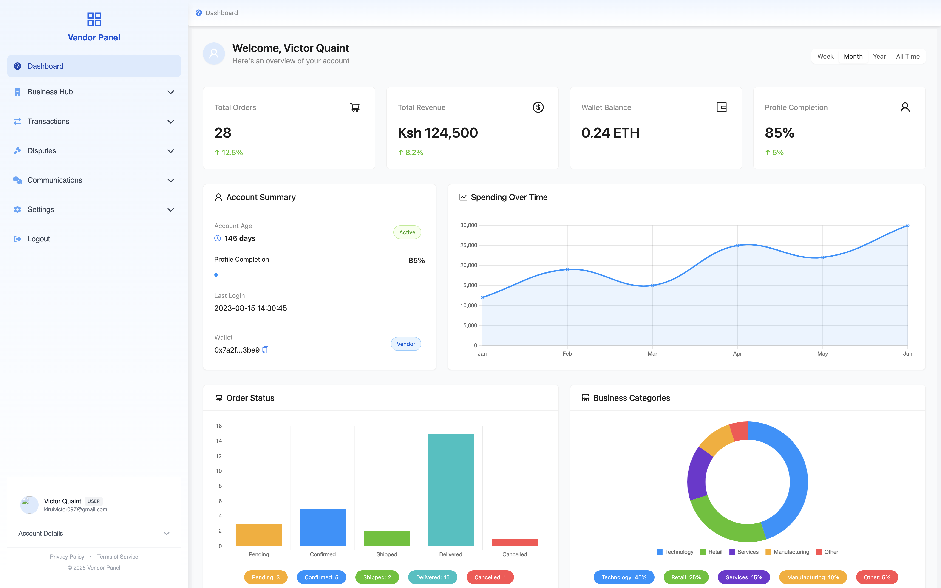
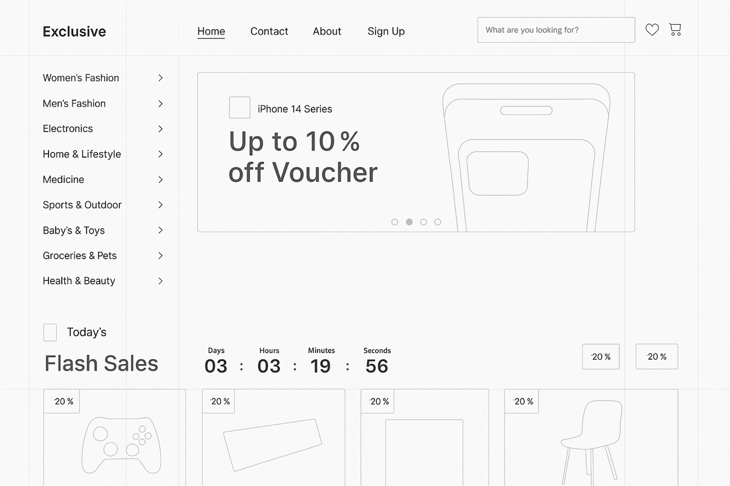

Usability considerations in UI design: We apply Jakob Nielsen’s usability heuristics and other UI principles:
- Visibility of system status: e.g., on the Order Status page, show clearly what stage the transaction is in (maybe a stepper graphic). Also loading indicators when an action is processing so user knows something is happening.
- User control and freedom: allow users to cancel out of actions (like a “Cancel” button on forms if they decide not to proceed), and confirm destructive actions (like confirming if they really want to raise a dispute or cancel a transaction).
- Consistency and standards: use common icons (a gear for settings, a bell for notifications, a house for home), and consistent terminology (don’t call the same thing “order” in one place and “transaction” in another confusingly – we stick to a term).
- Error prevention and handling: disable the “Buy Now” button if user is not logged in (with a tooltip “Please login to purchase”), thereby guiding them. Validate forms to catch errors before submission.
- Responsive design: ensure layouts adapt. We likely will design mobile wireframes as well where elements stack vertically, menu might become a hamburger menu, etc.
- Localization: possibly support a second language (Swahili) down the line, so we design with text externalization in mind (no hard-coded text in images, etc.) and allow space in UI for potentially longer translated text.
The UI design aims to create trust: by providing a professional look and feel, clear escrow status, and incorporating trust signals (like maybe a padlock icon or the word “Secure” in strategic places), the users should feel confident using Tredit. Furthermore, the UI will educate in small doses – for example, a tooltip “What is Escrow?” that when hovered or tapped, explains “Escrow means we hold the funds until you confirm everything is okay, ensuring safety for both parties.”
In summary, the physical UI design for Tredit translates the user requirements and process flows into a concrete interface that users will interact with. It ensures that all necessary functionalities (from account creation to initiating trades, to resolving issues) are easily accessible and understandable. Wireframes serve as a guide for front-end development and to communicate the intended layout during project development. With this design, we are confident that users will be able to navigate the system effectively and carry out escrow-protected transactions with ease, fulfilling the project’s goal of a secure and user-friendly escrow e-commerce platform tailored for the Kenyan market.

